Course Division-2083
Office Management and Accounting
Class 9

Chapter for First Term
S.N | Chapter | Remarks
1 | Office and employee
2 | Office assistant
3 | Office resources
4 | Accounting
5 | Journal

Number of question and Marks allocation for First Term

S.N | Chapter | No.n of Questions |  |  | Marks |  |  | Total
S.N | Chapter | V. Short | Short | Long | V. Short | Short | Long
1 | Office and employee | 2 | 2 |  | 1+1 | 5+5 |  | 12
2 | Office assistant | 1 | 1 | 1 | 1 | 5 | 8 | 14
3 | Office resources | 2 | 2 |  | 1+1 | 5+5 |  | 12
4 | Accounting | 3 | 2 | 1 | 1+1+1 | 5+5 | 8 | 21
5 | Journal (Numerical) | 3 | 1 | 1 | 1+1+1 | 5 | 8* | 16

Chapter for Second Term
S.N | Chapter | Remarks
1 | Correspondence
2 | Record Management
3 | Communication and IT
4 | Business (upto Partnership Firm)
5 | Ledger

Number of question and Marks allocation
S.N | Chapter | No.n of Questions |  |  | Marks |  |  | Total
S.N | Chapter | V. Short | Short | Long | V. Short | Short | Long
1 | Office and employee | 1 | 1 |  | 1 | 5 |  | 6
2 | Office assistant
3 | Office Resources | 1 | 1 |  | 1 | 5 |  | 6
4 | Correspondence | 1 | 1 | 1 | 1 | 5 | 8 | 14
5 | Record Management | 1 | 1 |  | 1 | 5 |  | 6
6 | Communication and IT | 1 | 1 |  | 1 | 5 |  | 6
7 | Business | 1 | 1 | 1 | 1 | 5 | 8 | 14
8 | Accounting | 1 |  |  | 1 |  |  | 1
9 | Basic Accounting Concept | 1+1 | 1 |  | 1+1 | 5 |  | 7
10 | Journal (Numerical) | 1 |  | 1 | 1 |  | 8 | 9
11 | Ledger (Numerical) | 1 | 1 |  | 1 | 5 |  | 6

Chapter for Third Term
S.N | Chapter | Remarks
1 | Business (Remaining)
2 | Assembly and meeting
3 | Subsidiary book

Number of question and Marks allocation
S.N | Chapter | No.n of Questions |  |  | Marks |  |  | Total
S.N | Chapter | V. Short | Short | Long | V. Short | Short | Long
1 | Office and employee | 1 | 1 |  | 1 | 5 |  | 6
2 | Office assistant | 1 | 1 |  | 1 | 5 |  | 6
3 | Office Resources
4 | Correspondence | 1 |  | 1 | 1 |  | 8 | 9
5 | Record Management | 1 | 1 |  | 1 | 5 |  | 6
6 | Communication and IT | 1 | 1 |  | 1 | 5 |  | 6
7 | Business | 1 |  | 1 | 1 |  | 8 | 9
8 | Assembly and meeting | 1 | 1 |  | 1 | 5 |  | 6
9 | Accounting | 1 | 1 |  | 1 | 5 |  | 1
10 | Basic Accounting Concept | 1 | 1 |  | 1 | 5 |  | 6
11 | Journal (Numerical) |  |  | 1 |  |  | 8 | 8
12 | Ledger (Numerical) | 1 | 1 |  | 1 | 5 |  | 6
13 | Subsidiary book (Numerical) | 1 | 1 |  | 1 | 5 |  | 6

Note:
Only one Short question will be asked from either chapter 8 or 9

Chapter for Final Term
S.N | Chapter | Remarks
1 | Trial Balance
2 | Govermment Accounting of Nepal

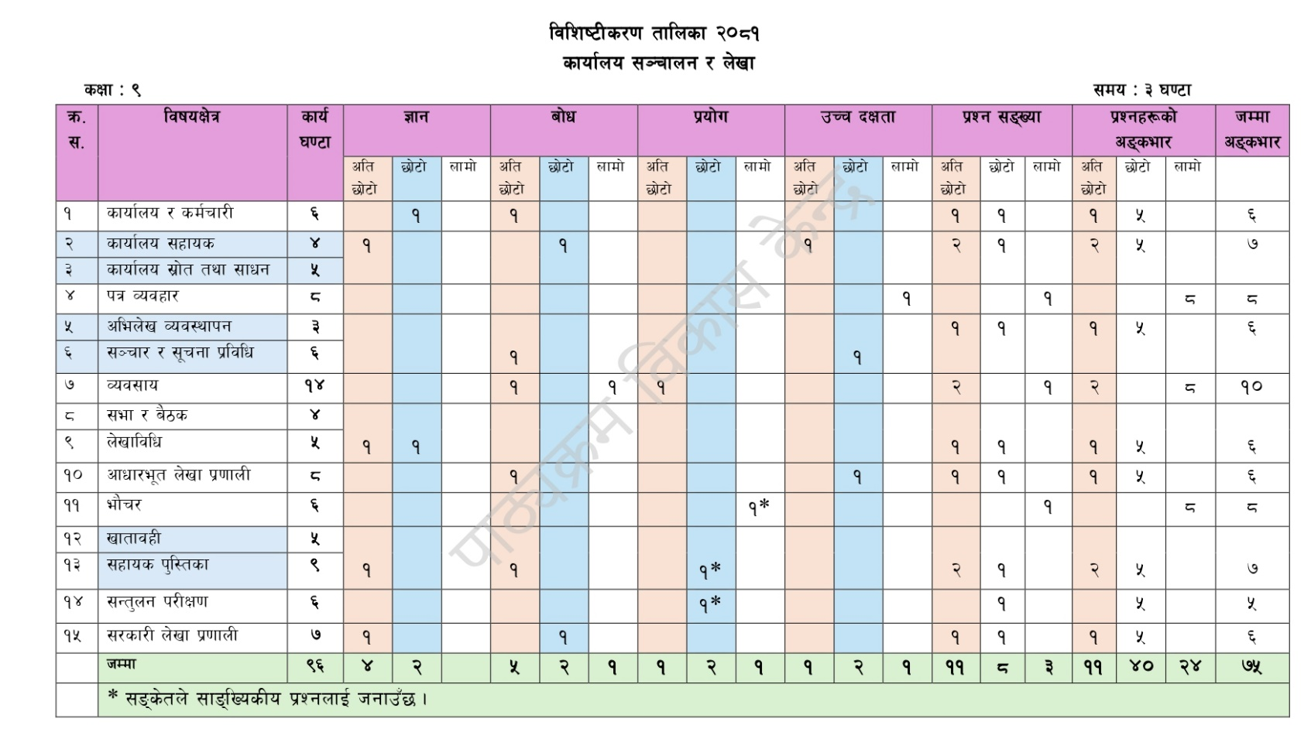
Grid for Final Term exam

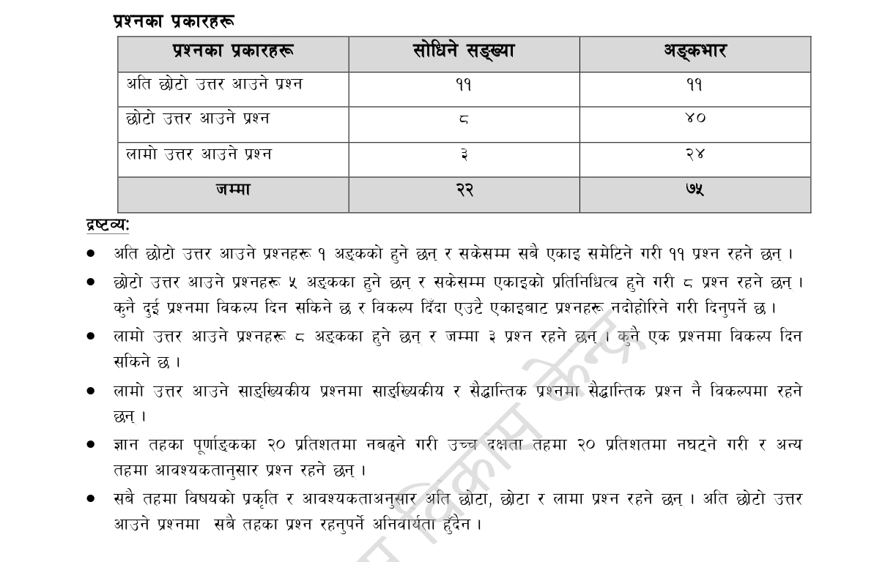
Course Division-2083
Office Management and Accounting
Class 10
Chapter for First Term
S.N | Chapter | Remarks
1 | Office Management and Procedure
2 | Bank, Insurance and Financial Innstitutions (only upto Banking)
3 | Introduction of Tax
4 | Bank Reconciliation Statement
5 | Accounting Error
6 | Final Account
7 | Government Accounting System in Nepal

Number of question and Marks allocation for First Term

S.N | Chapter | No.n of Questions |  |  | Marks |  |  | Total
S.N | Chapter | V. Short | Short | Long | V. Short | Short | Long
1 | Office Management and Procedure | 2 | 2 |  | 1+1 | 5+5 |  | 12
2 | Bank, Insurance and Financial Innstitutions (only upto Banking) | 3 |  | 1 | 1+1+1 |  | 8 | 11
3 | Introduction of Tax | 2 | 2 |  | 1+1 | 5+5 |  | 12
4 | Bank Reconciliation Statement (Numerical) |  | 2 |  |  | 5*+5* |  | 10
5 | Accounting Error (Numerical) |  | 1 |  |  | 5* |  | 5
6 | Final Account (Numerical) | 3 |  | 2 | 1+1+1 |  | 8*+8* | 19
7 | Government Accounting System in Nepal | 1 | 1 |  | 1 | 5 |  | 6

Chapter for Second Term
S.N | Chapter | Remarks
1 | Bank, Insurance and Financial Innstitutions (Remaining)
2 | Business accounting
3 | Expenditure Accounting (Journal Voucher, Bank cash Book, Statement of Expenditure)
4 | Revenue Accounting
5 | Store Accounting
6 | Fund Accounting and Retention Accounting
7 | Internal Control and Auditing

Number of question and Marks allocation
S.N | Chapter | No.n of Questions |  |  | Marks |  |  | Total
S.N | Chapter | V. Short | Short | Long | V. Short | Short | Long
1 | Office Management and Procedure | 1 | 1 |  | 1 | 5 |  | 6
2 | Bank, Insurance and Financial Innstitutions (only upto Banking) | 1 |  | 1 | 1 |  | 8 | 9
3 | Introduction of Tax  Business Accounting | 1 | 1 |  | 1 | 5 |  | 6
4 | Bank Reconciliation Statement (Numerical) |  | 1 |  |  | 5* |  | 5
5 | Accounting Error (Numerical) |  | 1 |  |  | 5* |  | 5
6 | Final Account (Numerical) | 1 |  | 1 | 1 |  | 8* | 9
7 | Government Accounting System in Nepal  Revenue Accounting  Expenditure Accounting (Journal Voucher, Bank cash Book, Statement of Expenditure) (Numerical) | 3 | 2 | 1 | 1+1+1 | 5+5* | 8* | 21
8 | Store Accounting  Fund Accounting | 2 | 1 |  | 1+1 | 5 |  | 7
9 | Internal Control and Auditing | 2 | 1 |  | 1+1 | 5 |  | 7

Chapter for Final Term
S.N | Chapter | Remarks
1 | Institutions involved in Government of Nepal
2 | Use of IT

Question pattern will be followed according to the SEE grid designed by CDC.

