COURSE DIVISION 2083
Health, Physical Education and Creative Arts.
Grade - VIII
First Terminal Examination
S.N. | Units | Lessons | P and P | remarks
1. | 1. Human Body | Chapter- 1. Nervous System  Chapter- 2. Glandular System  Chapter -3. Reproductive System | 1
2. | 2. Community Health and Mental Health | - Community Health and Their Solutions  - Introduction to Total Sanitation  - Water Seal and ECOSAN Toilets  - Introduction to School Health Screening Test  - Mental health problems.  - Conversion Disorder  - Law, Regulations and policies about Drug Abuse | 1
3. | 6.Physical Exercise and Drill | - Introduction to physical education and physical exercise  - Some important exercises  - Drill
4. | 10. Introduction to Art, Drawing And Colour | - Introduction to Nepali Art  - Basic rules of art  - Still life with Drapery Drawing  - Human forms drawing | 1

Grid for first terminal examination
Unit | knowledge |  |  | Understanding |  |  | Applicable |  |  | Higher Abilities |  |  | Total
 | VS | S | L | VS | S | L | VS | S | L | VS | S | L | VS | S | L
1 | 1 | 1 | 1 | 1 | 1 |  | 1 | 1 |  | 1 |  |  | 4 | 3 | 1
2 | 1 | 1 |  | 1 | 1 | 1 |  | 1 |  |  | 1 |  | 2 | 4 | 1
6 | 1 | 1 |  | 1 | 1 |  |  | 1 |  |  |  | 1 | 2 | 3 | 1
10 |  |  |  | 1 |  |  | 1 |  | 1 |  |  |  | 2 |  | 1
Total |  |  |  |  |  |  |  |  |  |  |  |  | 10 | 10 | 4

Second Term Examination
S.N. | Units | Lessons | P and P | Remarks
1. | 3.Food and Nutrition | - Introduction to Malnutrition and Its Causes  - Types Of Malnutrition, Malnutrition Related Diseases, And Preventive Measures.  - Introduction And Elements of food Security  - Protection of Consumers Health | 1
2. | 4. Disease, Safety and First Aid | -Sexually Transmitted Infections and Preventative Measures  - Non-communicable Diseases  - First Aid during accidents (Heat stroke, frost bite, Altitude sickness)  - Foreign Objects in Nose, Ear, Throat  - Safety Measures during Disaster | 1
3. | 8. Game | - Introduction to Games  - volleyball, football, basketball, kabaddi, Kho Kho , cricket,
4. | 11. Printing, Clay works, Collage and Construction | - Sculpturing through Carving Technique  - Stone carving, wood carving, clay carving  - Simple Image Construction from clay | 1

Grid for Second Terminal examination
unit | Knowledge |  |  | Understanding |  |  | Applicable |  |  | Higher Abilities |  |  | Total
 | VS | S | L | VS | S | L | VS | S | L | VS | S | L | VS | S | L
1 | 1 | 1 |  | 1 |  |  |  |  |  |  |  |  | 2 | 1
2 |  |  |  | 1 | 1 |  |  |  |  |  |  |  | 1 | 1
3 |  | 1 | 1 | 1 |  |  | 1 |  |  |  |  |  | 2
4 |  |  |  |  |  |  |  | 1 |  | 1 |  | 1 |  | 2 | 1
6 | 1 |  |  |  | 1 |  |  |  |  |  | 1 |  | 1 | 2
8 | 1 | 1 |  |  |  | 1 |  |  |  |  |  |  | 2 | 1 | 1
10 | 1 |  |  |  | 1 |  |  |  | 1 |  | 1 |  | 1 | 2 | 1
11 |  |  |  | 1 |  |  |  | 1 | 1 |  |  |  | 1 | 1 | 1
Total | 4 | 3 | 1 | 4 | 3 | 1 | 1 | 2 | 2 | 1 | 2 | 1 | 10 | 10 | 4
s

Third Term Examination
S.N | Units | lessons | P and p | remarks
1. | 5. Sexual and reproductive Health | - Social curiosity in Adolescents and Patience  - Pregnancy and safe abortion  - Family planning methods and its classification  - Artificial contraceptive devices (temporary and permanent)  - Menstrual cycle.  - Menstrual hygiene management | 1
2. | 7. Athletics and Adventurous Activities | - Introduction  - Relay race, Long distance race, long jump  High jump, shot put, Physical exercise for Athletics, Adventurous activities in air and in Snow,  -Prospects of adventurous Activities in Nepal. | 1
3. | 12. Singing and Playing Musical Instruments | -Introduction  - Music  - Technical Terminology of Music  - | 1
Grid for Third terminal examination
Unit | Knowledge |  |  | Understanding |  |  | Applicable |  |  | Higher Abilities |  |  | Total
 | VS | S | L | VS | S | L | VS | S | L | VS | S | L | VS | S | L
1 | 1 |  |  | 1 | 1 |  |  |  |  |  |  |  | 2 | 1
2 | 1 |  |  |  |  |  |  |  |  |  |  | 1 | 1 | - | 1
3 | 1 |  |  | 1 |  |  |  | 1 |  |  |  |  | 2 | 1 | -
4 |  |  |  |  |  |  |  |  | 1 |  |  |  | - | - | 1
5 | 1 |  |  |  |  |  |  |  |  |  | 1 |  | 1 | 1 | -
6 |  |  |  |  |  |  |  | 1 |  |  |  |  | - | 1 | -
7 | 1 |  |  |  | 1 |  | 1 |  |  |  |  |  | 2 | 1 | -
8 |  |  |  |  |  | 1 |  |  |  |  | 1 |  | - | 1 | 1
10 |  |  |  |  | 1 |  |  |  | 1 |  |  |  | - | 1 | 1
11 | 1 |  |  |  |  |  | 1 |  |  |  |  |  | 2 | - | -
12 |  |  |  |  | 1 |  |  | 1 |  |  | 1 |  | - | 3
total |  |  |  |  |  |  |  |  |  |  |  |  | 10 | 10 | 4

Pre BLE/ Final term examination
S. N. | Units | Lessons | P and P | Remark
1. | 9.Yoga | - Introduction  - Importance of yoga  - Ashtanga yoga  - Practice of Sukshma Kriya  - Surya Namaskar and its procedure  - Pranayama  - Bhastrika  - Bhramart  -Kapalbhati  - Anulom vilom  - Yogasan( Setu Bandhasana, Makarasana, Halasana) | 1
2 | !3. Dance and acting | -Dance  - Classicaldance,Traditionaldance,folk dance, Modern Dance,  - Dance with gesture using hand postures  - Folk Dance Jhyaure dance,sorathi Dance , Khyali Dance  - Acting (angik, Vachik, Aharya, Satwik) | 1

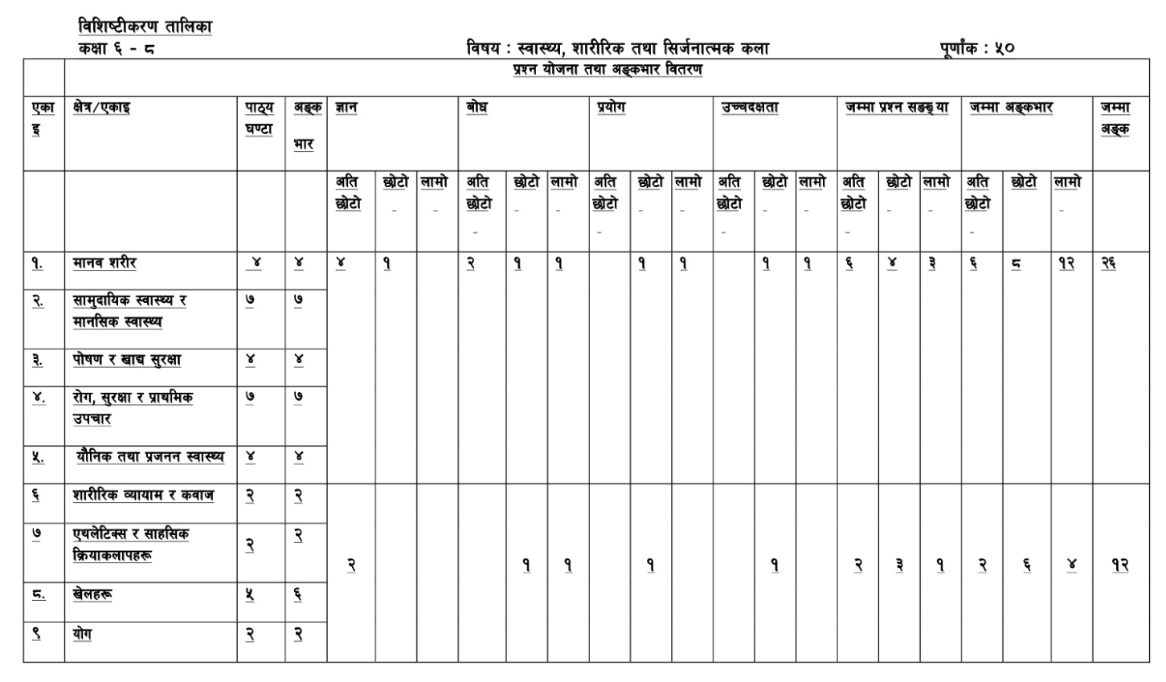
Grid for Pre BLE/Final Examination

